Exercises: Containers and Docker
Exercises for the "Containers and Clouds" course @ SoftUni

Lightstreamer Container
Lightstreamer (https://lightstreamer.com) is a web-based asynchronous messaging project.
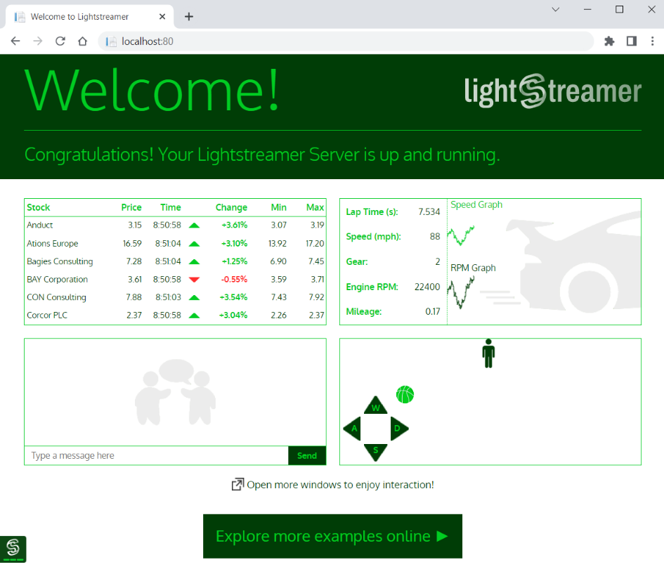
Your task is to run it in a Docker container. For running the Lightstreamer container:
- The image you need is lightstreamer:latest
- Your container's name should be ls-server
- Server works on port 8080, but should be accessed on localhost:80
- Container should be run in detached mode
Your container should look like this:
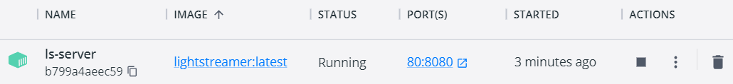
Make sure your container is created and Lightstreamer works in the browser. Then you can delete the container and the image.

Ghost Container
Ghost (https://en.wikipedia.org/wiki/Ghost_%28blogging_platform%29) is a free and open-source blogging platform, written in JavaScript. When run in a Docker container and accessed in the browser, it looks like this:
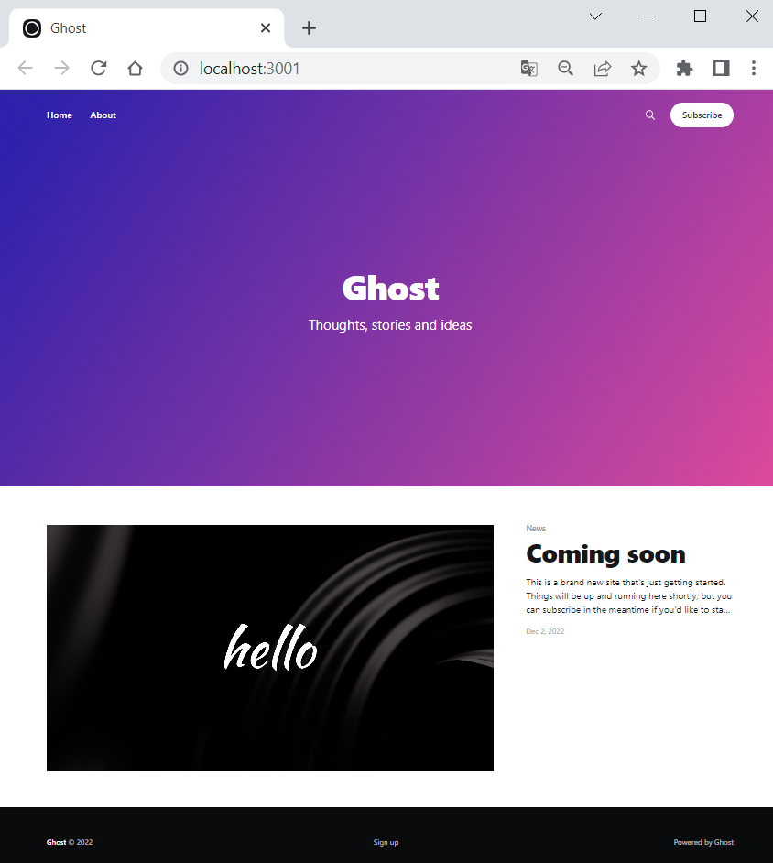
For running your Ghost container, follow these requirements:
- The image you need is ghost:latest
- Your container's name should be ghost-container
- Server works on port 2368, but should be accessed on localhost:3001
- You should set NODE_ENV=development as an environment variable with the -e option
- Container should be run in detached mode
Your container should look like this:

Note: if a "We'll be right back" message appears in the browser, it means that Ghost is still loading, so refresh the browser and everything should be alright.

Apache HTTP Server Container
Now you should run Apache HTTP Server in a Docker container.
- Use the latest image: httpd:latest
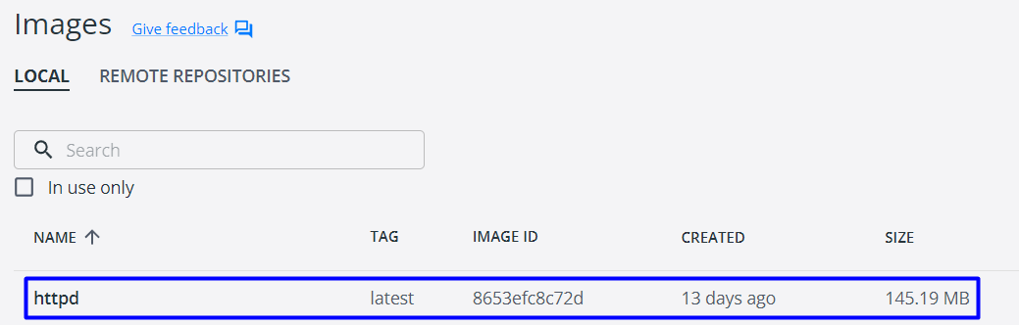
- Your container's name should be my-apache-app
- Server works on port 80, but should be accessed on localhost:8080
- Container should be run in detached mode
- You should create a volume – map current PowerShell (or another) directory to the container's directory /usr/local/apache2/htdocs/
Your container should look like this:

When accessed from the browser, it should list the files and folders from your local file system in the PowerShell directory you provided the server with, as well as in child directories: 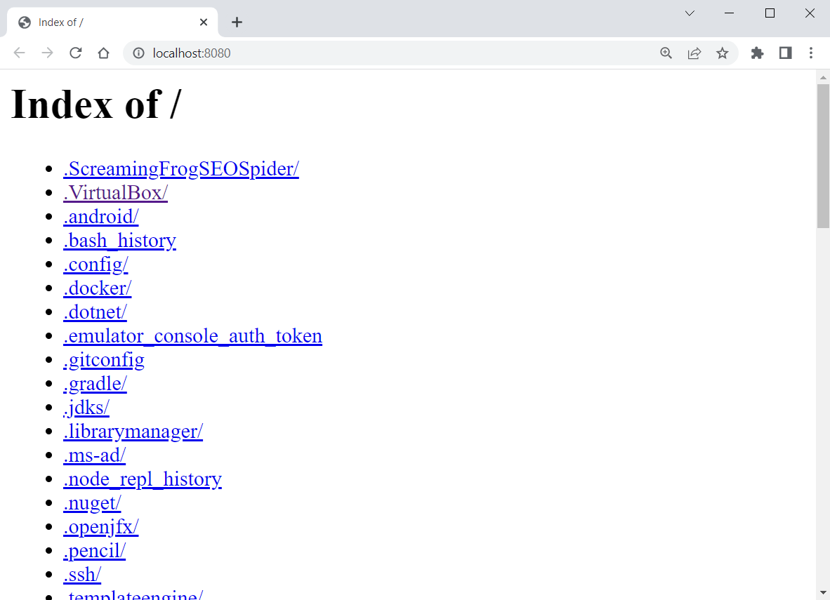
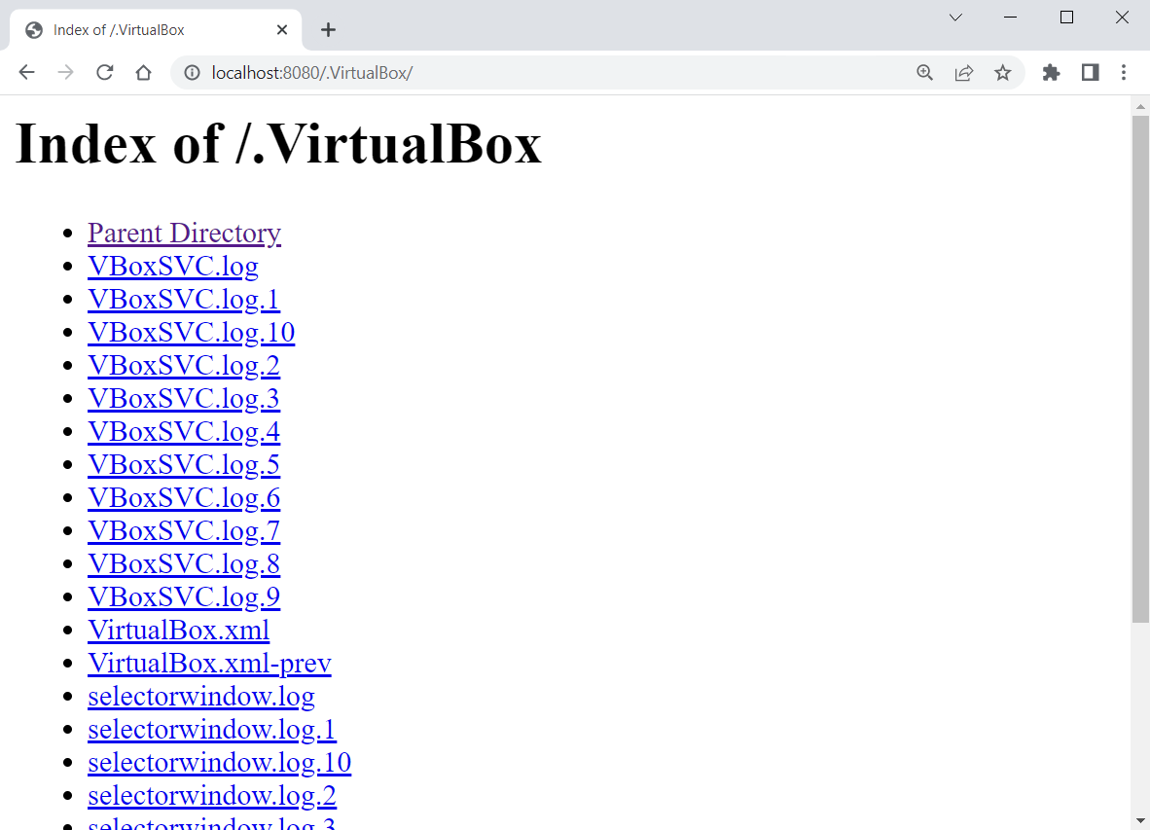
The local file system is accessed by the container because of the volume.
However, if the browser only shows you the "It works!" message (see below), then you didn't succeed in running the container properly and you should fix your command and try again:
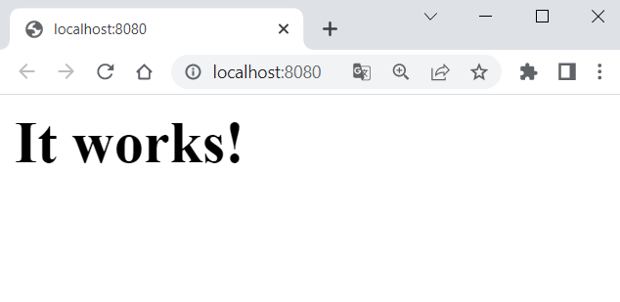

SQL Server Container
Our task is to run a container with an SQL Server database in it. To do this, we will need the following image from Docker Hub: https://hub.docker.com/_/microsoft-mssql-server.
You can look at the "How to use this Image" section to learn how to run the database container. However, we will also show and explain this step by step.

Create the Container
Start writing the multi-line run command for the Docker container:
Let's first take care of the environment variables needed for the SQL Server container. We should confirm the acceptance to licensing agreement with ACCEPT_EULA=Y:
We should also set a password for the database system administrator (sa) to connect to SQL Server once the container is running:
Note: your password should follow the requirements from the documentation: "This password needs to include at least 8 characters of at least three of these four categories: uppercase letters, lowercase letters, numbers and non-alphanumeric symbols".
Next, we should expose a port for the container. The server works on port 1433 and we will start it locally on the same one:
Then, we should create a volume, otherwise data will be lost when container is stopped, which is bad for a database container. We will name our volume sqldata and map it to the /var/opt/mssql directory, where SQL Server data is stored:
At the end, we will use the -d option to run the container in detached mode and will use the mcr.microsoft.com/mssql/server image:
Note: we didn't pull the image in advance but don't worry – it will be pulled automatically when the docker run command is executed.
Execute the above command and the container should be created:
